**Цвета и стили**

|  |  |  |
| --- | --- | --- |
| Основной фон | #BCD9D7 |  |
| Кнопки, рамка светлой кнопки и элементы | #76B0A7 |  |
| Текст | #2A3A3A |  |
|  | | |
| CornerRadius | 20 | - |

**Используемые расширения в Visual Studio:**

1. HTML CSS Support
2. Live server
3. Prettier
4. Tailwind CSS IntelliSense
5. Tailwind Docs

**Используемые технологии и порядок их установки:**

1. Flask <https://habr.com/ru/articles/783574/>
2. NodeJS https://nodejs.org/en
3. Tailwind CSS <https://tailwindcss.com/docs/installation/using-vite>
4. <https://bootstrap.pypa.io/get-pip.py> C:\Users\AnitaPC\AppData\Local\Programs\Python\Python313\python.exe get-pip.py
5. pip install flask flask_sqlalchemy pip install mysql-connector-python pip install pymysql pip install pyodbc
6. https://learn.microsoft.com/ru-ru/sql/connect/odbc/download-odbc-driver-for-sql-server?view=sql-server-ver16

.\.venv\Scripts\Activate.ps1

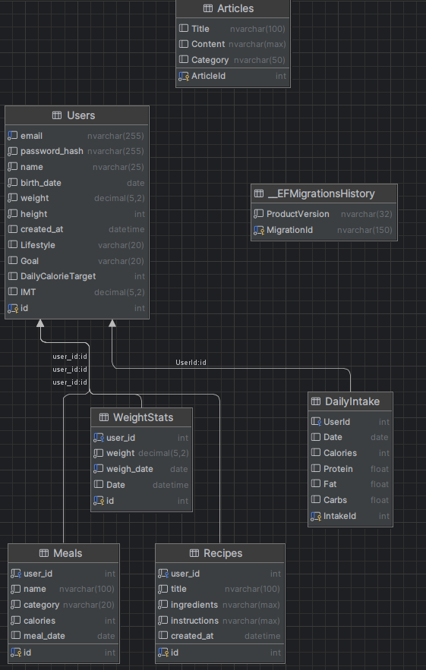

Installing collected packages: typing-extensions, pymysql, MarkupSafe, itsdangerous, greenlet, colorama, blinker, Werkzeug, sqlalchemy, Jinja2, click, flask, flask_sqlalchemy

Successfully installed Jinja2-3.1.6 MarkupSafe-3.0.2 Werkzeug-3.1.3 blinker-1.9.0 click-8.1.8 colorama-0.4.6 flask-3.1.0 flask_sqlalchemy-3.1.1 greenlet-3.1.1 itsdangerous-2.2.0 pymysql-1.1.1 sqlalchemy-2.0.40 typing-extensions-4.13.2